**Detection-Dog Survey Protocol for Yosemite National Park**



Sean M. Matthews1, David S. Green1, Breezy Jackson2, Mike McDonald2, Sarah Stock2,

Heath Smith3, and Jennifer Hartman3

1Institute for Natural Resources, Oregon State University

2Yosemite National Park

3Rogue Detection Teams

1 July 2020

# Introduction

Yosemite National Park provides an important intact wilderness ecosystem to support populations of large-ranging carnivore species, including Sierra Nevada red fox (*Vulpes necator*) and cougar (*Puma concolor*). The Sierra Nevada red fox, a subspecies of red fox, is one of the rarest mammals in the Sierra Nevada. The Sonora Pass Distinct Population Segment (DPS) is currently under consideration as endangered under the U.S. Endangered Species Act. To determine the current status of this red fox population, biologists from the National Park Service, U.S. Fish and Wildlife Service, California Department of Fish and Wildlife, University of California, Davis, and Oregon State University have partnered to gain essential baseline information about the fox’s population size, range, and habitat requirements.

Another carnivore of conservation interest is the cougar, also known as puma, cougar, and panther. This apex predator plays an outsized role in the ecology of the Sierra Nevada. As a wide-ranging species, it is an indicator of habitat connectivity (Penrod 2000) and provides top-down regulation of prey populations (Ripple and Beschta 2008).

Estimating population parameters of carnivore species can be challenging because these species often occur at low densities, are restricted to limited geographical distributions, and are often wary of traditional survey devices (e.g., live traps, hair snares; Thompson 2004). Thus, surveys for these species frequently result in low probabilities of detection and high uncertainty around population parameter estimates (Williams et al. 2002). Appropriate evaluation of conservation actions relies on precise estimates of population parameters and monitoring for changes in these estimates over time.

Recent advances in data integration using hierarchical frameworks provide opportunities to inform detection probabilities and improve estimates of population parameters (Chandler and Clack 2014). Noninvasive survey methods are cost-effective and can be combined with data integration techniques to increase detection probabilities, making them an appealing option to survey for elusive carnivores (Long et al. 2008). Noninvasive techniques provide an important alternative to capturing and collaring animals that avoid the stress of capturing and handling and achieve the same monitoring objectives.

The primary purpose of this project is to gain a greater understanding of the current distribution and ecology of cougars and Sierra Nevada red foxes in Yosemite. Our objective is to estimate the abundance, genetic relatedness, species range, and habitat associations of Sierra Nevada red fox and cougar by combining detection data from detection-dog teams and remote cameras. We intend for this field protocol, in conjunction with the Mountain Lion Survey Protocol Using Trail Cameras in Yosemite National Park, to 1) orient staff to the project and our objectives and 2) provide step-by-step instructions for carrying out project tasks. Nevertheless, a written protocol is a living document and improves with experience and collaborative discussion. We look forward to working and learning together!

# Objectives

Our main objective is to estimate the population size and habitat associations of Sierra Nevada red fox and cougar in Yosemite National Park using non-invasive methods. We will use carnivore scat collected by detection-dog teams and photographs from remote cameras to determine species occupancy. Scat collected will be genetically analyzed to species and those identified to be cougar or Sierra Nevada red fox will then be identified to individual by the Mammalian Ecology and Conservation Unit at the University of California Davis. Collaborators at the Institute for Natural Resources at Oregon State University will use the genetic identifications, photographic-detection data and, a combination of spatial capture-recapture and occupancy analyses to estimate population size and habitation association of cougar and Sierra Nevada red fox in Yosemite National Park.

**Methods**

## Background

This protocol is adapted from The 2016-2020 Sierra Nevada red fox in Yosemite National Park survey protocol (Eyes et al. 2018), Guidelines for Sierra Nevada red fox surveys and monitoring (Sacks and Quinn et al. 2018), Klamath-Siskiyou Carnivore Project camera protocol (Matthews and Green 2018), Rogue Detection Teams Field Protocol (Smith and Hartman 2019), and personal communications with Justin Dellinger with the California Department of Fish and Wildlife. Further details can be found in Eyes et al. (2018) on using a Garmin GPS (Appendix 5), using Irfan View (Appendix 6), safety (Appendix 8), and personal gear and overnight trips (Appendix 9).

## Supplies for Detection-dog Surveys and Scat Collection

* Handheld park radio with extra battery (fully charged)
* GPS with extra AA batteries (fresh)
* Compass
* Park map
* Map of CDFW hexagon grid cells and camera locations
* Multi-tool (e.g., Leatherman)
* Android phone with camera and ODK Collect for data entry (including a back-up phone or other way to collect data like paper data sheets)
* Supplies for carrying out detection-dog poop, e.g., NRS dry bags, liner bags, and dog-poop bags
* Scat collection kit
  + Latex gloves
  + 95-100% EtOH (e.g., Sigma-Aldrich, Product No.: 459844)
  + 15-mL centrifuge tubes or other leak-proof screw-top vials (e.g., Fisher Catalog No.: LSV#14955160B or USA Scientific, Item No.:1475-1611)
  + Fine-point alcohol-proof permanent markers
  + Applicator sticks, coffee stirrers, popsicle sticks
  + Scotch tape
  + Parafilm
  + Paper bags
  + **Ziplock bags**
  + **Desiccant**
  + **Rubber bands**

## Survey Sites

Our 2019 sampling design was based on a grid system of 10.4 km2 (4 mi2) hexagonal cells developed for multispecies mesocarnivore monitoring by the California Department of Fish and Wildlife. Three-hundred and thirty-eight hexagons intersect Yosemite National Park (3027 km2; 1169 mi2). One-hundred and forty hexagons grouped in 20 clusters of seven hexagons were surveyed by detection-dog teams for carnivore scat in 2019 (Figure 1).

A detection-dog team surveyed each cluster of 7 hexagons over an approximate 7-day period (including travel to/from clusters). The handlers referred to a mapping program (Locus) on their phone to stay in the general vicinity of the 7 hexagon cluster and to easily navigate to a determined location while seeing a track of where they have been (Figure 2). The field schedule starts when a detection-dog team moved from one cluster to the next, and then the schedule repeated itself.

* 1. 1 travel *survey* day (portered) to camp
  2. 1 rest day
  3. 3 survey days
  4. 1 rest day
  5. 1 travel *survey* day (portered) out of camp

The intention of the hexagon-based design was to distribute the sampling effort across the Park and a wide-range of elevations, vegetation communities, and terrain conditions. We prioritized areas of the park with higher levels of predicted Sierra Nevada red fox and cougar habitat suitability for the selection of survey hexagons. The hexagon-based design, however, limited detection-dog teams from accessing locations and terrain features (e.g., saddles, ridges) suspected to increase the probability of detecting scat. We will thus implement a modified survey design for sampling in 2020.

In 2020, backcountry basecamps and front-country takeoff locations will be selected by NPS personnel within or in vicinity of selected hexagons (Figure 3). We selected areas of the Park with higher predicted Sierra Nevada red fox and cougar habitat suitability. We prioritized areas not sampled in 2019 and plan to resample a subset of some areas sampled in 2019 with the highest predicted habitat suitability. NPS personnel will map suggested routes for detection-dog teams to access terrain features suspected to increase the probability of detecting Sierra Nevada red fox and cougar scat (e.g., saddles, ridges). Detection-dog teams will survey along three routes from each backcountry basecamp or front-country takeoff location, traversing 5-15 km per survey day (Figure 4). On some longer trips, detection-dog teams will travel and basecamp together. On both survey days, detection-dog teams will survey two different routes. On the second survey day the first team will survey a new route, while the second team will conduct a species-targeted survey. In the Dorothy hexagon the second team will conduct a targeted survey for Sierra Nevada red fox. In the Canyons, Rancheria, and Hetch Hetchy hexagons, the second team will conduct a targeted survey for cougar. Handlers will process collected samples at the end of each survey day upon returning to their camp or vehicle. Thus, the 2020 field schedule will go as follows:

1. travel *survey* day (portered) to camp
2. rest day
3. survey day 1, both teams survey and process samples
4. survey day 2, both teams survey and process samples
5. rest day
6. travel *survey* day (portered) out of camp

Surveys in the same area may start from different locations, particularly in front-country areas, where opportunities provide greater access to a particular area from an alternate starting point (e.g., Figure 5).

Detection-dog teams will survey for scats during their dedicated survey days and also on travel days. NPS personnel will carry the handler’s backpack contents during travel days to allow the handler to conduct surveys carrying a lightweight pack containing appropriate survey gear and sampling supplies. Data and effort will be recorded the same way during dedicated surveys, during travel/surveys, and regardless of whether or not the travel is occurring on a trail with the dog leashed. Detection teams should aim to survey along routes suggested by NPS personnel and areas with high probability of scat from target species, however, safety of the handler and the dog takes precedence. The handler has the flexibility to move across the landscape selecting habitat features relevant to the target species, while also being cognizant of safety factors that might affect the dog’s overall stamina and productivity, such as weather, terrain, temperatures, direct sun, other wildlife, roads, and people. Detection-dog teams should prioritize searching for scats in areas most likely frequented by cougars and red foxes, such as along ridges, saddles, drainages, constriction points, and trails; and by fishers in and among drainages, large trees, black oaks, and meadows.

**NPS personnel and Rogue handlers will follow a communication protocol.** Rogue teams will check in every morning before surveys and evening when at camp. **Two days prior to a resupply (by 3 pm)**, NPS personnelconfirms with Rogue that they will be arriving on a certain day and which device to message. Rogue requests specific resupply needs. **One day prior to a resupply**, Rogue confirms with NPS personnelthe location of delivery and the time of day the NPS personnelwill arrive. **On the day of delivery**, the NPS personnelgives an updated ETA. Depending on needs, a resupply may include a fully charged anchor, sampling supplies, human and dog food, dry bag for containing dog feces, and packet with updated protocol and maps of relevant survey areas with any suggested routes/camping locations pre-marked. NPS personnel and handlers must always carry research permit. It is recommended that handlers also carry with them the project fact sheet (see Appendix 1).

For backcountry surveys (Figure 4), it may be more efficient for the detection-dog teams to camp at the basecamp selected by NPS personnel, however this is not required and they can choose the location of the camp with respect to the terrain and areas of highest likelihood of detecting target species. In general, detection-dog teams will survey along routes suggested by NPS personnel and areas with high probability of scat from target species in an out-and-back clover-leaf pattern as they survey back to camp (Figure 4). For front-country surveys (Figure 5), detection teams may elect to start sampling at different locations within each hexagon (e.g., trailhead or other access point) each day so long as they aim to maximize the coverage and the number of individual scats belonging to target species that can be collected.

Detection-dog teams will survey for four to five of seven days, including 2 travel days, prioritizing coverage of high suitability habitat of target species. Samples will be collected and stored as outlined in the next section (*Scat Surveys*). Days spent traveling and surveying to the next survey area will count as working days. Detection-dog teams will survey for scat while traveling to the camp location and record the handler and dog GPS tracks when traveling between camp locations. Ideally the dog will be off leash during these days, so as to replicate the same sampling effort as on other days.

In addition to the distributed effort represented in Figure 3, NPS personnel will also add focused, targeted surveys for Sierra Nevada red fox and fisher in areas where they have been detected previously. Survey effort and the number of days of sampling will be collaboratively determined based on remaining survey days available at the end of the 2020 survey season.

## Scat Surveys and Target Species

The evening prior to surveying, the handler will prepare all gear and materials needed for the next day of surveys. This includes charging all electronics (data phones, GPS units, Bluetooth device) and securing scat collection materials, food, and water for both the handler and the dog for the next day. The handlers backpack will be packed and ready to go, including first aid kits, a radio or InReach safety check-in device, dog reward toys, dog boots, leash, head lamp, and any other necessary gear or personal comfort gear.

On each survey day, the handler will wake before first light or soon after to feed the dog. Dogs need 30-60 minutes to digest before commencing field work. The dog will be fed two meals per day. Meals are divided between morning and evening. The dog may also receive a small meal in the middle of the day to maintain their energy if required.

When a survey is to begin, the dog is fitted with their safety vest and dog harness, this lets the dog know work is beginning. The handler should always display their affiliation in a professional and obvious way (e.g., uniform shirt, backpack patch, and uniform hat) that indicates they are working in the park. The dogs’ movements will be tracked every 5 meters throughout the day using a standalone GPS data logger (860e) placed inside the dog’s harness. The handler has a Bluetooth GPS (Columbus 990) that connects to the Moto X4 cellular phone. This is to conserve the battery of the phone and to have a stronger GPS signal for accuracy when recording sample locations or track logs. These data are necessary for assessing search effort and imperative for modeling (see Thompson et al. 2012 for an example with fisher [*Pekania pennanti*]).

The dog and handler will hike for 6-8 hours covering 5-15 km or more. See Figures 4 and 5 for example detection-dog GPS tracks. The handler will always adhere to the expectations expressed in the Contractor Services Agreement between Rogue Detection Teams and Yosemite Conservancy.

In 2020, above 9,000 ft elevation, detection-dog teams will survey and collect scats of Sierra Nevada red fox, gray fox, coyote, and cougar (or anything that might be one of these species). Below 9,000 ft elevation, detection dog teams will survey and collect scats for cougar, fisher, and marten. In 2019, detection-dog teams collected scats of Sierra Nevada red fox, cougar, and fisher at all elevations. Above 8,000 ft elevation, detection dog teams also collected gray fox and coyote scats.

**In 2020, handlers will not complete forms for scats they do not collect.** In 2019, handlers collected information for scats from any other carnivore species that the dogs hit on (e.g., marten, bobcat), or scats that don’t adhere to the elevation limitations above, as long as the handler was confident in species identification. The form included the GPS location, the date/time, and the species identification. When scats of non-target species were detected, forms were only filled out once per species per 100m. For example, if the dog hit on marten, the handler filled out a form. If the dog then hit on marten <100m from this initial scat, a form was not filled out. *These non-target species scats will not be collected.*

When the dog locates a scat, they will alert by sitting and making eye contact with the handler. They will remain at the scat until the handler approaches. Depending on both the strength and confidence of the dog’s response at the scat as well as the handler’s visual assessment, the handler will then decide to either reward and collect, reward but not collect (if the sample is from a non-target species), not reward but collect (this happens if the sample is indistinguishable from a non-target species but the target is so rare that collection is necessary), not reward and not collect (this happens if the dog’s response is weak or if the sample is from a non-target species for this study). The final scenario may also apply when the dog is trained on other targets but for the particular project, that sample is not needed. In this way the dog is taught to not continue to alert to those samples. If the handler decides to reward, the ball is tossed away from the sample to avoid potential contamination of the sample. The ball may be tossed a short distance, or the dog may be engaged in tug; both are kept brief to maintain the dog’s energy and tosses are kept short to ensure dog safety.

When the handler decides to collect a sample, they open and complete an Open Data Kit (ODK) form on their android data phone. Data will be collected at the location of each collected scat. ODK Collect forms include the following data fields:

1. Date/Time (automatically generated)
2. GPS coordinates (Phone is attached to a bluetooth GPS, so this field is automatically generated)
3. Species (A drop-down list of all the species the teams would like to detect.)
4. Sample ID
5. Photo of Sample, with a sharpie or other marking tool for scale
6. Gestalt (A drop down menu where "low, medium," or "high" is chosen for confidence on the species identification. This field is mostly useful for us and the handler for when we receive results back, but genetic labs can also utilize this field if they would like to limit the number of samples they run based on both the human and dog confidence on the species)
7. Sample freshness (A drop down menu of "very old”, “old”, “good condition” and "fresh." This is obviously opinion based and not useful except to the extent that once again, a lab can choose if they only want to run "high confidence, good condition" to "fresh" samples and if there are funds leftover, they can choose to run the "medium to low" confidence and "old to very old" scats).
8. Notes

The handler will take the opportunity to water or rest the dog, if deemed necessary by the handler. This can be anywhere from 5-30 minutes depending on each dog’s stamina, age, the temperature and where in the survey the team is (i.e. beginning, middle or end).

## Scat Collection

Handlers should take precautions while collecting scats to avoid unnecessary exposure to diseases by wearing gloves and sanitizing their hands. Ideally, pregnant women should not handle scats because of risk of exposure to *Toxoplasma gondii*. Scats can also contain various parasites including *Echinococcus multilocularis* (or *E.granulosis*) which are rare but potentially very dangerous if ingested or inhaled.

1. Wear latex or nitrile gloves **(new gloves for every scat)**
2. In the field, collect the entire scat in paper bag labeled sequentially throughout the season starting at a unique, pre-determined starting number for each handler. Note, in 2019 samples were numbered sequentially starting at 001 each day of sampling. Later at camp, this sample should be labeled:

**“YOSE-DSG-05AUG19-001G”** where:

* 1. YOSE identifies the project
  2. Three initials of the handler
  3. Date formatted as 05AUG19
  4. A sequential number starting at a unique, pre-determined starting number for each handler
  5. Genetic samples are labeled with a “G” following the sequential number
  6. Diet samples are only labeled with a sequential number

1. Record all field data in ODK Collect.
2. Preserve a sample of each scat in ethanol (EtOH) **BEFORE THE END OF THE DAY OF SAMPLE COLLECTION**
   1. Add at least 8 mL of 95 – 100% EtOH in a 15mL tube (Figure 5)
   2. Note the level of EtOH in tube before putting scats in
   3. Wearing a new pair of gloves for every scat, put ~2 mL (sugar-cube sized piece or pieces) of the scat in a 15mL tube; add scat until the EtOH level rises 2-3 mL (Figure 5).
      1. Using the wooden applicators (new one for each scat) or gloved hands, cut or break off samples of the scat from the tapered ends and widest portions of the scat. These locations often have the largest number of epithelial cells. The tapered ends are particularly useful because they have a large surface to interior ratio. Sample from as many of these locations as possible to increase the probability of collecting epithelial cells.
   4. Always put ethanol in the tube first; NEVER pour ethanol after scat is in tube
   5. **Label tube with an EtOH-proof pen** as in (2) above and additionally mark and engrave with the metal tip of a mechanical pencil the Sample ID on the top in case alcohol spills and clears labeling off side (Figure 5).
   6. **Use parafilm to seal cap to vial**
   7. Use scotch tape to cover label on tube to protect ink
3. Save the remainder of the scat for diet analysis in the original, (now fully) labeled paper bag. Do your best to protect the paper bags containing the samples from UV light and humidity during transport to the office. Paper bags should then be sealed in one-gallon sized plastic bags containing ¼ cup of desiccant. **If scat or bag is moist from environmental conditions, place the paper bag individually into its own quart-sized plastic bag with 2 T of desiccant. Use rubber bands to secure paper bags.** **Note: stapling is discouraged because it makes for extra work in the lab and affects the integrity of the bags for long-term storage.** These scats will be sampled for diet analyses, see Diet Sample Preparation below.
4. **Pack out ethanol tubes using these three strategies to limit leaks and to ensure that labels remain legible: 1) Put the labeled and secured vial in the rubber glove you used for sampling. Label the outside of the rubber glove with the scat number (not the entire sample number, just the scat number). 2) Bundle the vials (that are now in gloves) with a rubber band and place the bundle in a quart-sized zip lock. Secure the ziplocked bundle with another rubber band. 3) Label the ziplock bag with sample numbers and the date (e.g., 001-010, 22SEP19). 4) Keep vials upright.**
5. Storage: Keep scat samples stored in ethanol **UPRIGHT** in a test tube rack in a cool, dry, dark place (protected from UV light and humidity) until transferring to the laboratory. **DO NOT** store in freezer.

## Diet Sample Preparation

Once back at the office, add 1 mL of 95 – 100% EtOH in a 2-mL Eppendorf tube (Figure 6). Then collect three, lentil-sized pellets of scat from the interior of the scat. Place the samples in an EtOH-filled Eppendorf tube. It is important to remember moisture is the enemy here. **Label each sample using an ethanol-proof pen as YOSE-DSG-08Aug19-001**. As with the genetic samples, keep diet scat samples stored in ethanol **UPRIGHT** in a test tube rack in a cool, dry, dark place (protected from UV light and humidity) until transferring to the laboratory. **Store these samples in the refrigerator.**

## Opportunistic Tissue Collection

## If carcasses are encountered during surveys that could belong to Sierra Nevada red fox or fisher, collect tissue samples from the ear and nose (including the skin and cartilage) or whatever may be present. Cut these tissues up into small pieces and place in a tube with ethanol following similar procedures as above. It is important that the pieces of tissue are small enough that the ethanol can penetrate it.

## Opportunistic Scat Collection

Observers providing support to scat detection teams will also collect cougar, red fox, and fisher scats opportunistically while moving throughout Yosemite to and from deployments. All scat should be collected and preserved using the same methods indicated above. **Observers should also collect GPS tracks of their movements throughout Yosemite as they provide support to account for their effort.** Upload tracks from each day setting cameras or providing detection-dog support as a GPX file to this folder U:\EP Resources\00. Wildlife Branch\00.Mammals\Mountain Lion\GIS - Mountain Lion Spatial Data\2019_Tracks

Label each day’s tracks with the date and your initials. Ex:  20190708_CRK (YearDayMonth_Initials)

## Data Downloading and Dog Care

When possible, handlers will download data daily at the end of the day. With ODK, this requires the ODK Briefcase to be downloaded on a computer (can be completed offline) into an Excel file that can be projected into GIS software. All track logs, both human and dog, are also downloaded and put into separate folders.

Once the data are downloaded, the gear is charged for the next day. The handler will then look over the dog for any scrapes, ticks or other abrasions and treat them. This is the dog rest time and they remain in a calm, cool quiet place (typically their crate but if camping, then in a tent) so that they can rest for the next day of surveys. The dog is fed dinner, the handler prepares for the next day, and the process is repeated the next day.

## Leave No Trace

During surveys, leave no trace practices will be applied at base camps and along survey transects and travel routes. Handlers will collect and carry out detection-dog feces from the field. NPS field personnel will assist in carrying out dog feces.

## Genetic Samples to U.C. Davis

Genetic analyses to identify species and individuals will be conducted by Ben Sacks and Cate Quinn at the Veterinary Genetics Laboratory at U.C. Davis. Samples will be driven to U.C. Davis at the middle and end of the field season. Complete a SampleDatabase.xlsx file and contact Ben Sacks by email (bnsacks@ucdavis.edu) when samples are ready for transport. The SampleDatabase.xlsx file will be data exported out of ODK Collect.

Scat samples for genetic analyses should be packaged for transport using the following guidelines:

1. Each tube has parafilm-sealed cap with at least 3 mL airspace in each 15-mL tube to enable liquid expansion
2. Tubes are in a polystyrene rack
3. The above package is contained in a sealed Ziploc bag
4. This package is wrapped in newspaper or other absorbent material sufficient to take up full contents if leaked
5. All contained in a rigid box

# Literature Cited

Chandler, R. B. and Clark, J. D. (2014), Spatially explicit integrated population models. Methods Ecol Evol, 5: 1351-1360.

Eyes, S., S. Stock, and B. Jackson. 2016. The Sierra Nevada red fox in Yosemite National Park: 2016-2017 survey protocol. National Park Service, Yosemite National Park. El Portal, CA.

Long, R.A., P. MacKay, W.J. Zielinski, and J.C. Ray. 2008. Noninvasive survey methods for carnivores. Island Press. Washington, D.C.

Matthews, S.M. and D.S. Green. 2018. Klamath-Siskiyou Carnivore Project camera protocol. Oregon State University, Institute for Natural Resources. Portland, OR.

Penrod, K. 2000. Missing linkages: Restoring connectivity to the California landscape. Proceedings of the Conference of November 2, 2000. San Diego Zoo, CA.

Ripple W.J. and R.L. Beschta. 2008. Trophic cascades involving cougar, mule deer, and black oaks in Yosemite National Park. Biological Conservation 141: 1249–1256.

Sacks B.N. and C.B. Quinn. 2018. Guidelines for Sierra Nevada red fox surveys and monitoring. University of California. Davis, CA.

Smith, H. and J. Hartman. 2019. Rogue Detection Teams field protocol. Rogue Detection Teams.

Thompson, C.M., J.A. Royle, and J.D. Garner. 2012. A framework for inference about carnivore density from unstructured spatial sampling of scat using detector dogs. Journal of Wildlife Management 76:863:871.

Thompson, W.L. 2004. Sampling rare or elusive species: Concepts, designs, and techniques for estimating population parameters. Island Press. Washington, D.C.

Williams, B.K., J.D. Nichols, and M.J. Conroy. 2002. Analysis and management of animal populations. Academic Press. San Diego, CA.

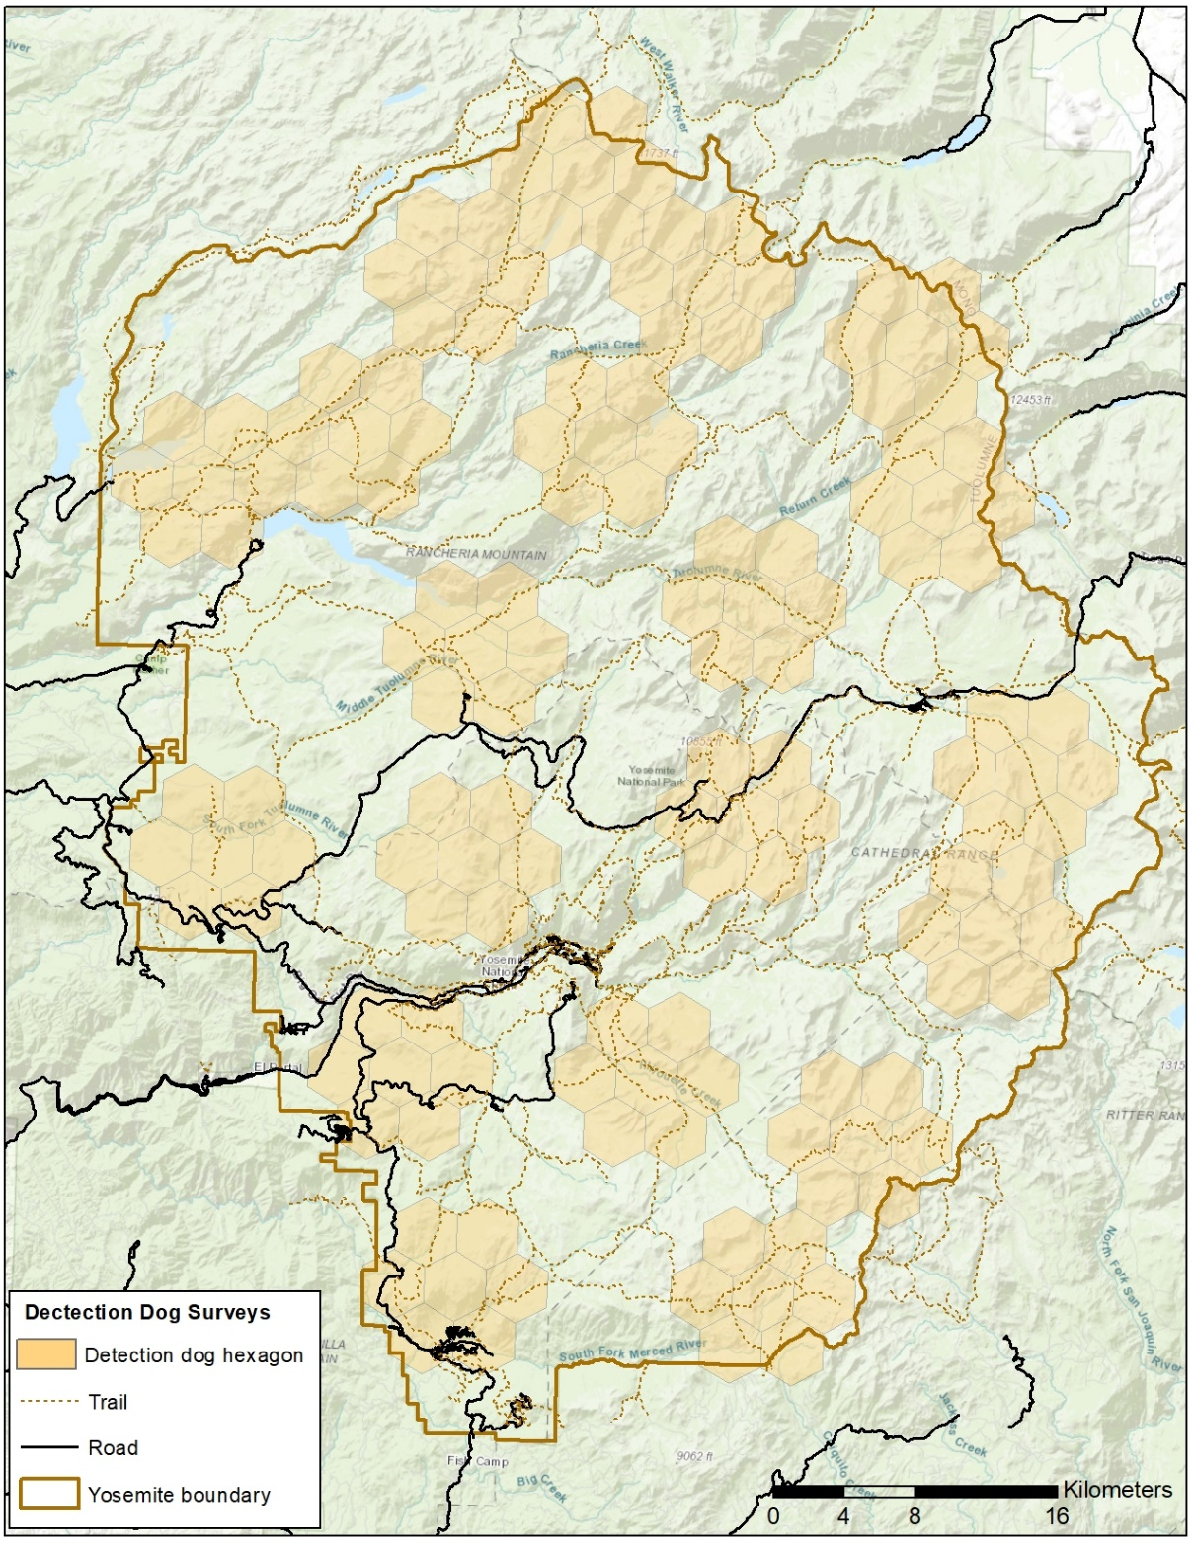

Figure 1. Survey plan for 2019 - A subset of 10.4 km2 (4 mi2) hexagonal cells developed for multispecies mesocarnivore monitoring by the California Department of Fish and Wildlife. Selected hexagons will be used to survey for carnivore scat using detection-dog teams (brown hexagons) in Yosemite National Park.

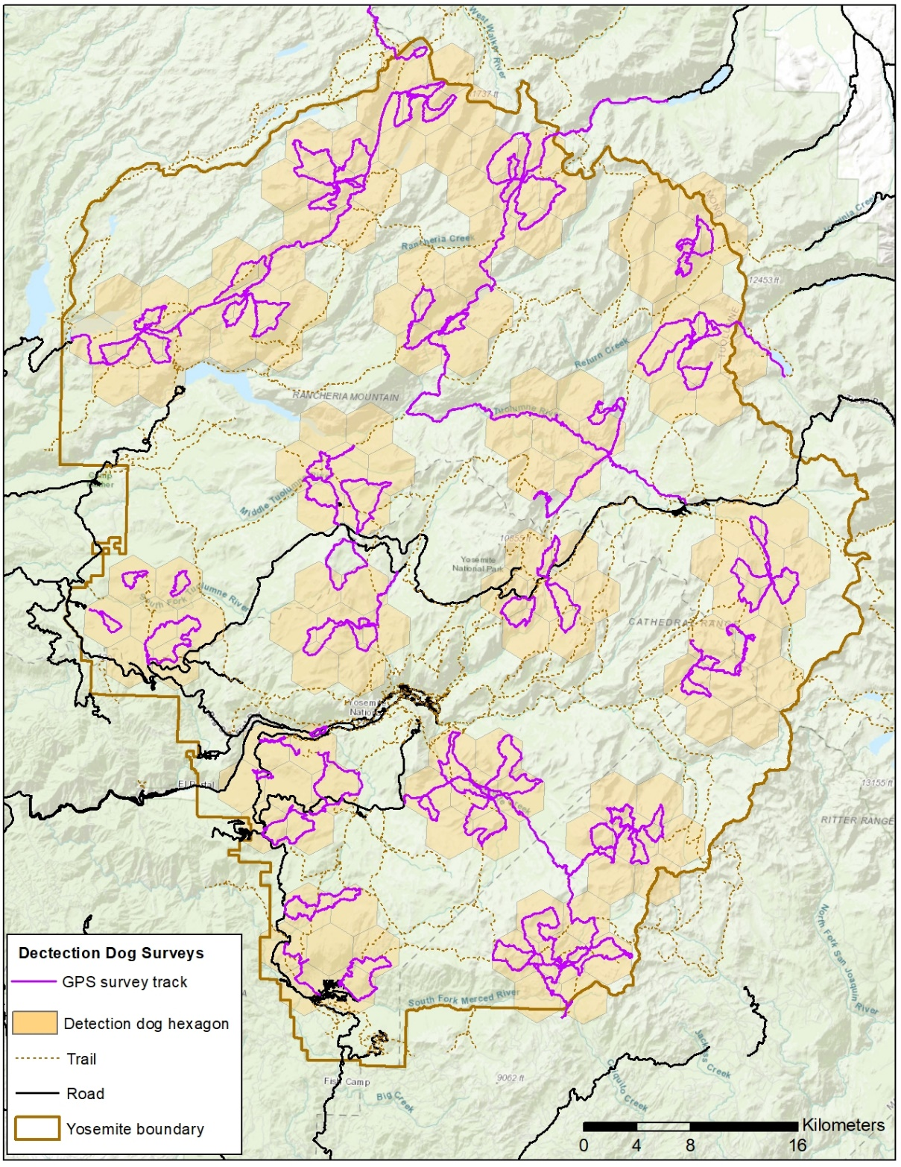

Figure 2. Tracks surveyed by three Rogue Detection Teams sampling 1,283.6 km for carnivore scat in Yosemite National Park between 2 August and 14 October 2019.

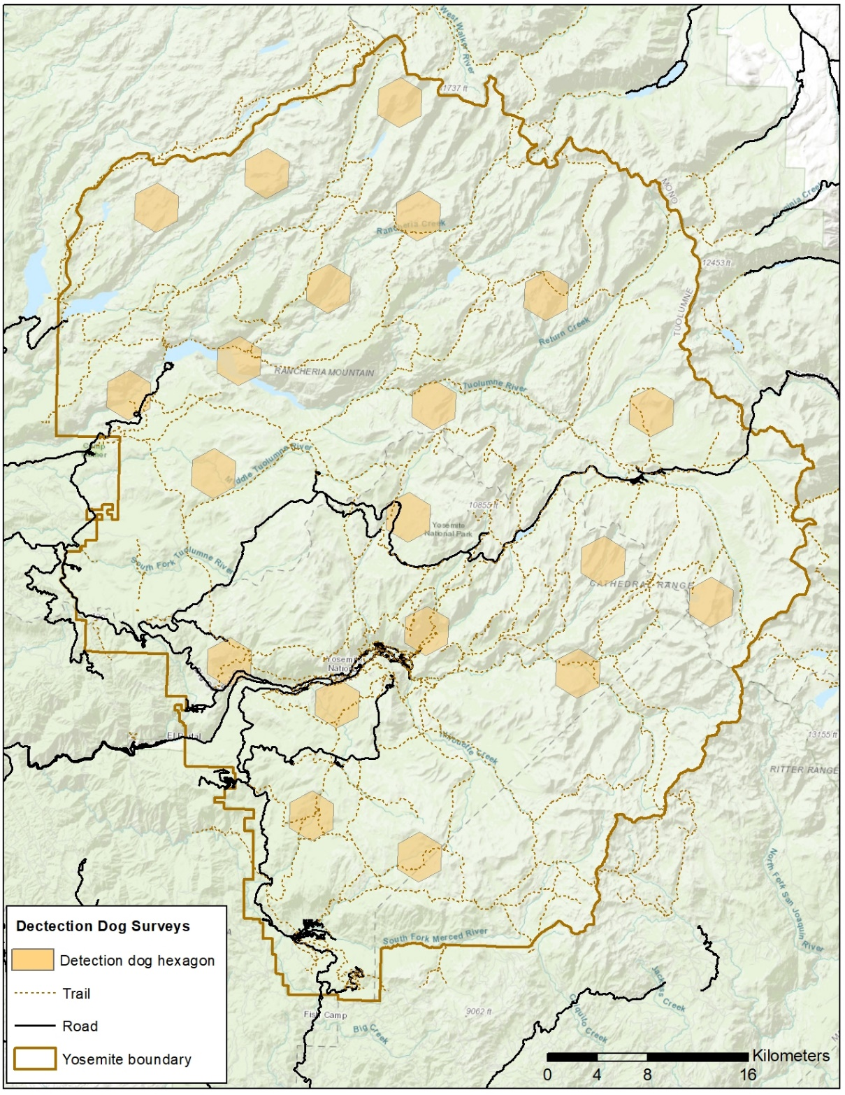

Figure 3. Survey plan for 2020 - A subset of 10.4 km2 (4 mi2) hexagonal cells developed for multispecies mesocarnivore monitoring by the California Department of Fish and Wildlife. Selected hexagons will be used to guide surveys for carnivore scat using detection-dog teams in Yosemite National Park.

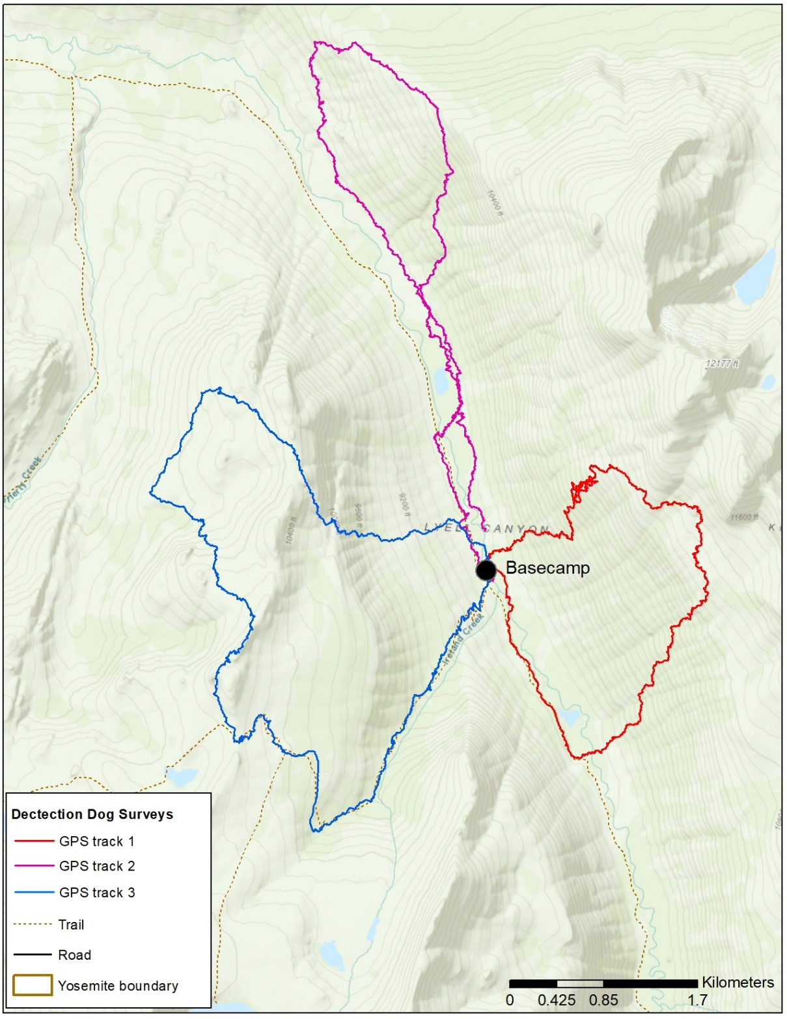

Figure 4. Example backcountry survey by detection-dog team. Detection-dog teams will establish camp at the designated basecamp during backcountry surveys. Starting from camp, detection-dog teams will survey three proposed routes, traversing 5-15 km on each route. Trails may be used to maximize efficiency of travel and effectiveness of finding scats.

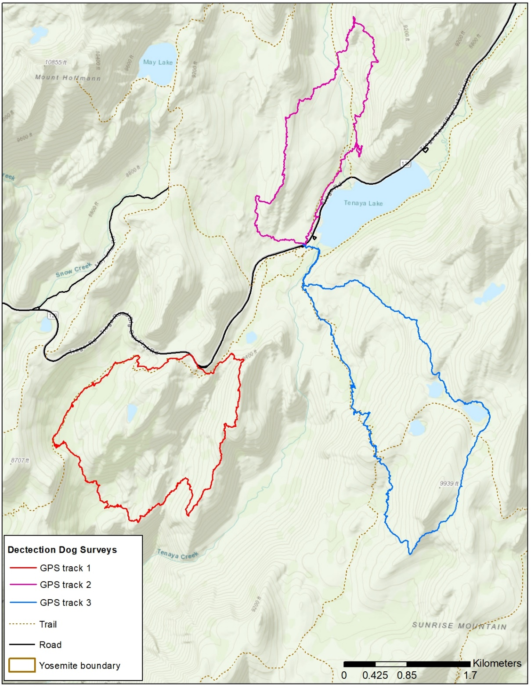

Figure 5. Example front-country survey by detection-dog team. Detection-dog teams will utilize roads and trails to maximize survey effort and distribute effort, traversing 5-15 km on each route. Detection teams may start sampling at different locations (e.g., trailhead or other access point) each day so long as they aim to maximize the coverage and the number of individual scats belonging to target species that can be collected. Teams do not need to use the same starting point each day.

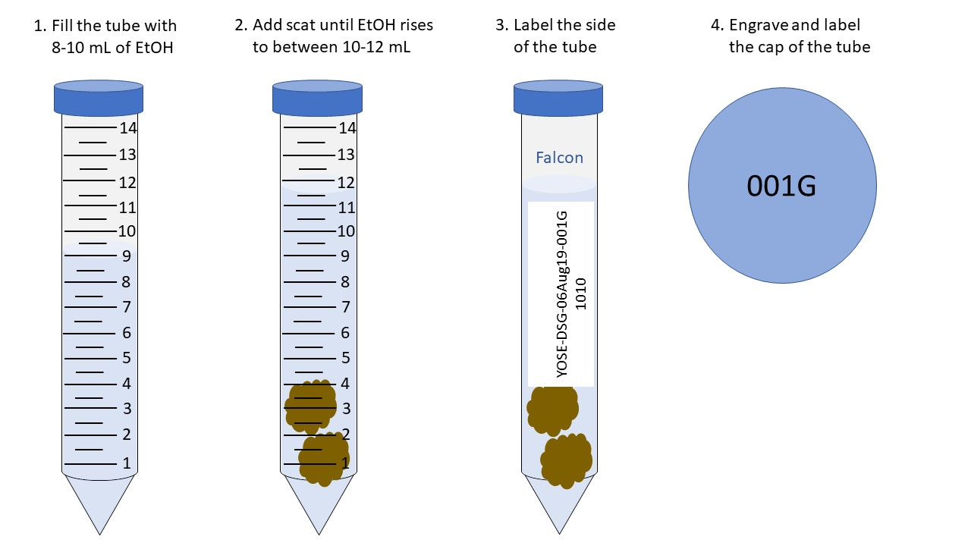

Figure 6. Schematic for transferring scat samples to 15 mL centrifuge tubes and labeling for genetic study. The label for each scat sample should be “YOSE-DSG-06Aug19-001G”, where this refers to a sample collected in Yosemite, by dog handler DSG, on August 6th, 2019, and unique number identifying the sample (001). In 2019, each handler labeled samples sequentially starting at 001 each day of sampling. In 2020, each handler will start with a unique number and label each sample sequentially throughout the season. The “G” indicates that this is a sample that will be used for genetic analyses (not diet analysis). The labeling on the sample vial lid will be engraved in with the metal tip of a mechanical pencil. The 1010 on the side of the vial indicates the time of the sample collection (as insurance for any ethanol-induced labeling problems).

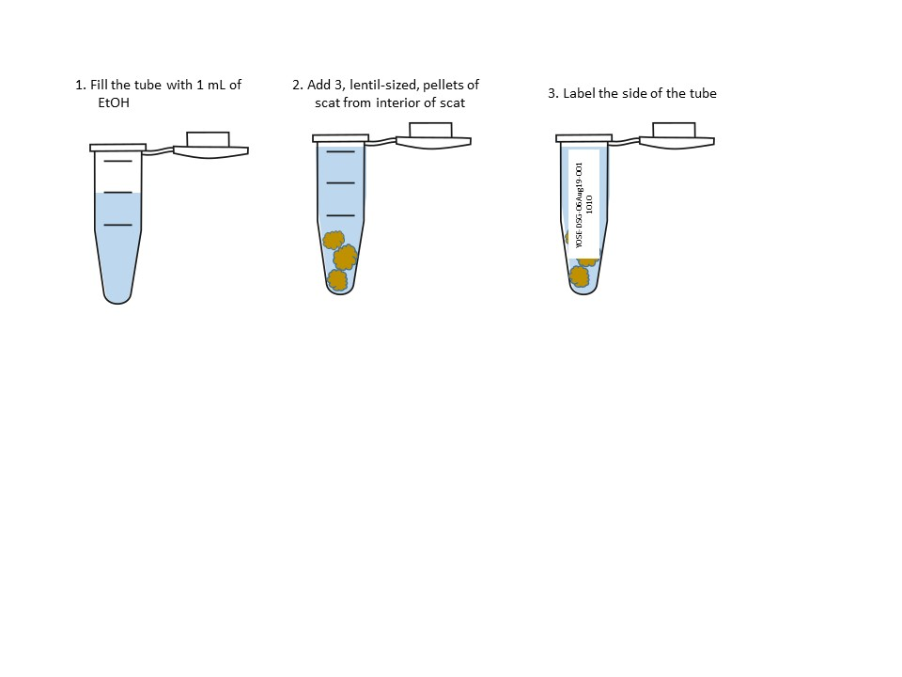

Figure 7. Schematic for transferring scat samples to 2 mL Eppendorf tubes and labeling for diet study. The label on each scat should be “YOSE-DSG-06Aug19-001”, where this refers to a sample collected in Yosemite, by dog handler DSG, on August 6th, 2019, and this was the first sample collected on that day (001). The 1010 indicates the time of the sample collection (as insurance for any ethanol-induced labeling problems).

Appendix 1. FACT SHEET – Conducting Biological Surveys Using Dogs in Yosemite National Park

From July 7 - October 1, 2020, two to three detection-dog teams consisting of one dog and one handler will survey for Sierra Nevada red fox, cougar, and fisher scats throughout Yosemite. The detection-dog teams will begin surveying for scats in the high country and slowly move to lower elevations as the season progresses. They will be working in the field for ~70 days in 2020. After 2-years of surveys, they will have covered ~80% of the park using a grid-based study design. Reasons for using trained scat-detection dogs include (1) dogs are more effective at detecting scats than humans, (2) the scat collection method is less invasive than traditional capture/collar methods, and (3) genetic analysis of scats will reveal population estimates and habitat use for Sierra Nevada red fox and cougars. Biologists will use this information to protect these elusive carnivores in Yosemite.

Whereas dogs are occasionally used in Yosemite’s Wilderness for search and rescue purposes, dogs are rarely used for carrying out biological surveys in Yosemite. The purpose of this fact sheet is to explain the rationale for using dogs and to answer anticipated questions about the program. The following list of considerations will always be met in order to ensure detection dogs minimize impacts to wildlife and visitor experience.

* Rogue Detection Teams will ensure that dogs are trained to not pursue wildlife.
* Rogue Detection Teams will ensure that dogs are on tight command. That is, dogs will remain near the handlers and return to handlers immediately when commanded. Dogs will be called back and leashed when wildlife (e.g., bird’s nest) or visitors are present. When dogs are not surveying, they will be on leash or resting inside a tent.
* Rogue Detection Teams will ensure that dogs and handlers are easily identifiable. Dogs will work in harnesses with sewn patches indicating they are Rogue Detection Team working dogs. Handlers will wear a uniform (e.g., a shirt or vest) indicating they are Rogue Detection Team handlers.
* Rogue Detection Teams will ensure that dogs are kept up to date on all vaccination including but not limited to Rabies, Leptospirosis, Bordatella, and DA2PPC. In addition, dogs will receive Revolution treatments on the 1st of each month to prevent infection by heartworm, ticks, and fleas. If needed, dogs will also be treated with Frontline or a tick collar.
* Rogue Detection Teams will immediately notify the NPS of any clinical illness detected in the dogs, stop working, and take the dog for assessment by a veterinarian. In addition, if any clinical illness is detected in the 30 days prior to arrival in Yosemite, Rogue Detection Teams will notify the NPS and seek treatment by a veterinarian. Signs of illness include, but are not limited to, vomiting, diarrhea, lethargy, fever, coughing, sneezing, difficulty breathing, and skin lesions.
* Rogue Detection Teams will provide to the NPS a veterinary health certificate issued within 30 days of arrival in Yosemite by a licensed and USDA-accredited veterinarian for each dog. This will include a fecal screening with no evidence of internal parasites.
* Rogue Detection Teams will communicate to the NPS their emergency plans for the dogs should they become sick or injured.
* Rogue Detection Teams will ensure that dogs are not currently on antibiotic medication while working in Yosemite.
* Rogue Detection Teams will follow Leave No Trace guidelines for disposal of waste. Canine feces will be packed-out and placed in the trash. Human feces will be buried in a 6-8-inch-deep hole at least 200 feet from any water source. All toilet paper will be packed-out.
* Rogue Detection Teams will adhere to Yosemite National Park food storage protocols including use of a bear can for storage of all food, scented items, toiletries, and dog food.
* Rogue Detection Teams will follow Leave No Trace principles for camping in wilderness and observe any location-specific camping regulations.
* The NPS will always provide at least one field technician to facilitate sample collection, carry samples out of the backcountry, and resupply food and supplies to dog teams. NPS techs will not interact with the dogs. When possible, the NPS will provide campsites and access to administrative facilities for dog teams to camp and shower between hitches.

For more information about the program, please contact Sarah Stock ([sarah_stock@nps.gov](mailto:sarah_stock@nps.gov)).